Marshall, here are the elements for the landing page mock-up:

1. **We begin with our proposition, the first half of which is this:**

It’s noisy out there. You get ten seconds to earn the next ten seconds.

(This is a slight re-write from what’s on my Wix site.)

To illustrate this “it’s noisy out there” premise, I’ve sent you the file of the video currently running on my Wix site. As alternates, I’ve also sent two high-res photos: “Shutterstock_It’s noisy out there,” versions 1 and 2. If you prefer photo over video, pls. select the photo you think is more compelling. I do like the video because it’s active and on point, but it would have to be applied in a way that doesn’t overwhelm a finely-designed page.

1. **The second half of my proposition is my company name and tagline.**

The noise of everyone pitching creates a stark choice for all who sell: be vivid or be gone. For our logo and tagline we’ll need a font that is strong yet considerably more refined than what you see on my Wix site. Below offers just a sense of what I’m thinking. But since this font is pulled from Microsoft Office, it looks kind of “stock”; I’m hoping that you have access to more customized fonts. Also, please feel free to play around with the logo and tagline’s layout, spacing, etc. All I know for sure is that I want a logo/tagline that looks assertive but refined (confident and elegant); something that looks like it was designed by a fine hand. (Perhaps the “b” could be in a contemporary script; just an idea…)

*b*VIVID

or be gone

*b*VIVID or be gone

Here’s how I see the page flowing from here, although I’m open to a better idea:

1. **After the logo and tagline comes a brief statement of who we are and what we do:**

Noisy markets create a stark choice for all who sell: be vivid or be gone.

Crisp, evocative and hard to ignore, the communications we craft piece the din.

Think of us as you would a cloud service: there when you need us, up to speed quickly, remarkably effective, and gone when our work is done;

available to re-engage instantly.

1. **Next comes the “Projects” piece. I like this look and feel from Jingling Gate:**

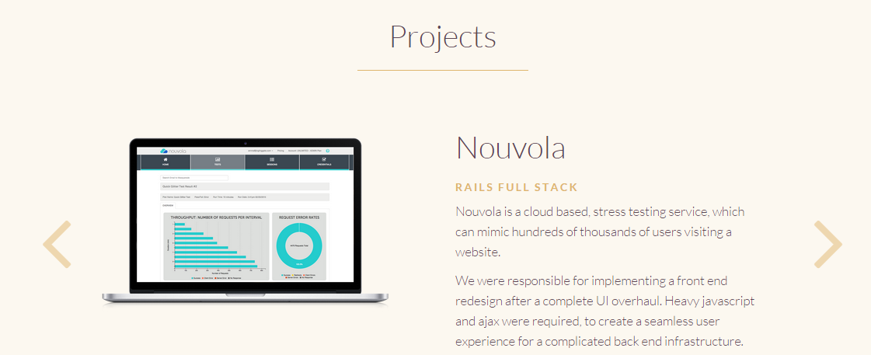

I’d like our landing page to show the six projects currently featured on my Wix site (of course, I’ll edit down the copy to the 50 or so words accommodated by the treatment above.) For this mock-up, here’s text and an image for each of two projects… so that we can a sense of what this section of the page would look like:

(See next page)

**(Marshall, please let me know if you need originals of the images below, or whether you can grab what’s here and paste them to the mock up. Obviously, I’ll send hi-res originals of all images when you construct the actual page)**

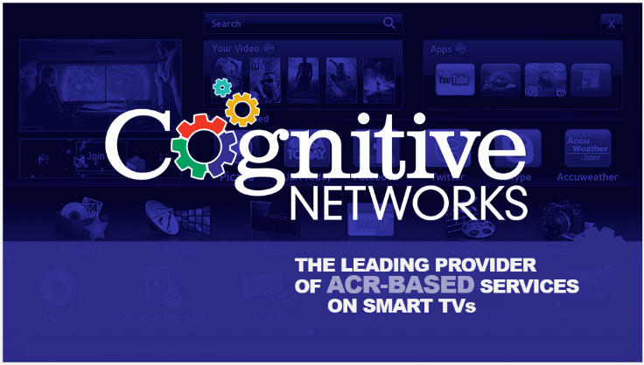Cognitive Networks

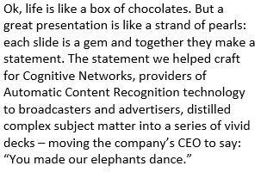Presentations

 Deloitte

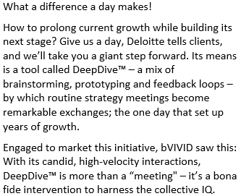 Collateral

1. **Next comes the list of services, like this section from the Jingling Gate page:**



Text as follows:

Services

(Marshall, I have 12 service offerings. For the sake of this mock up, let’s create real type for three of them, and then dummy the rest so that we can see how all 12 would look.)

As follows:

Presentations

______

You’ll make your case and keep it crisp with help from decks by bVIVID.

Slides flow smoothly, visuals pop, and text is concise and on point.

The story comes alive and culminates in a call to action.

Collateral

______

Collateral: the word connotes secondary value. It needn’t.

We produce brochures, sales materials and other collateral

crafted to resonate with your markets and spark conversations.

Keynotes

______

We prepare keynoters for all podiums, from industry gatherings and investor conferences to special venues like The World Economic Forum. Those we’ve helped include hundreds of executives across Oracle, PepsiCo, Deloitte and dozens more.

**Marshall, here are the rest of the Services. Each will get 25–35 words of text:**

White Papers

Success Stories

Lead-Generating Emails

Bylined articles

Video

Top-Tier Media Placements

Book Publishing

Events

Organizational Communications

1. **Next comes the Team section:**

Over a dozen of America’s best writers, designers and videographers support the work of bVIVID, a firm managed by its two partners:

**David Gilman**

Acknowledged as one of the finest writers of corporate, marketing and organizational communications, and a deft developer of creative talent, David is in the business of equipping executives and their teams with tools to spark and sustain productive conversations: those essential to closing sales, spurring investment, building alliances and motivating employees.

David began his career writing for *The New York Times.* From there he moved into business, spending two years in internal communications at Dun & Bradstreet, three years in marketing at KPMG, five years in public relations at PepsiCo, and two years in the brain trust of Michael Milken, whose case he helped craft for the court of public opinion.

Known for distilling complexity into vivid communication, David launched bVIVID to help clients capture the urgency of their work and convey it in ways that compel response. As the firm's chief creative officer, he leads the task of shaping deliverables for all clients.

David is a graduate of Stony Brook University, where he served as editor-in-chief of the college newspaper and won the Buskin Prize for journalism, administered by Newsday.

He runs six miles a day and does some of his best thinking between miles two and six.

**Gina Trent**

Editor *par excellence,* Gina’s fine touch is evident in many of our signature projects; those for PepsiCo, Deloitte and Vendavo among them.

Gina joined bVIVID in 2006 after a long stint in public relations. At various stages of her PR career she specialized in pharma, fashion and consumer electronics, and represented some of the world’s best brands in these categories: Pfizer, Toshiba, and Liz Claiborne among them. She is a graduate of Bard College and holds a Master’s degree in management from NYU.

(next page)

1. **Next comes two client quotes, like this one from Jingling Gate:**

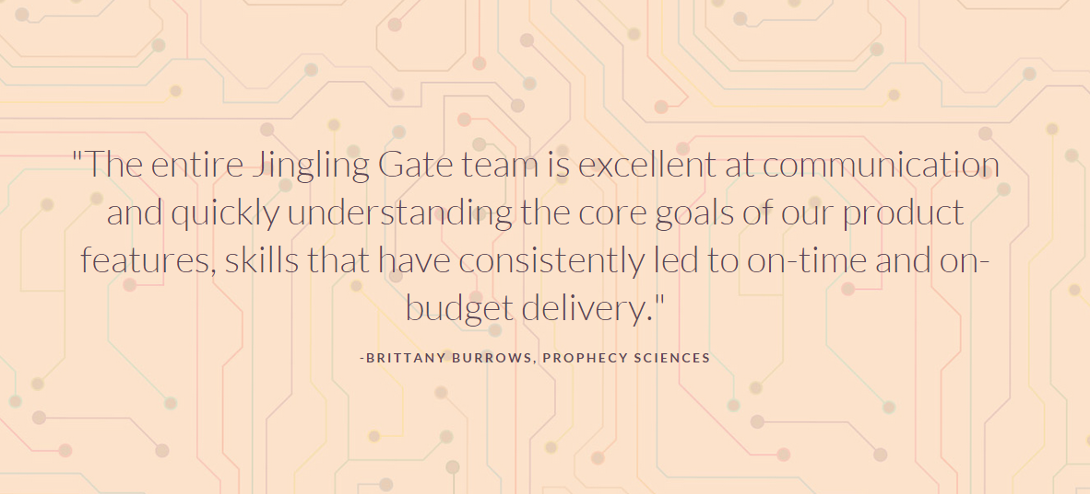

Text for two client quotes as follows:

“bVIVID does the hard work of understanding what we do and why it’s compelling. That’s refreshing. I’ve seen too many communications firms content to tinker around the edges and deliver work that does little more than recycle clichés.”

**Michael Raynor, Deloitte Consulting**

“Your work has bite.”

**Joe Boissy, Vendavo**

(next page)

1. **Clients**

Marshall,

Paul has the files of these logos. Please lay them out to look more linear; perhaps in a grid:

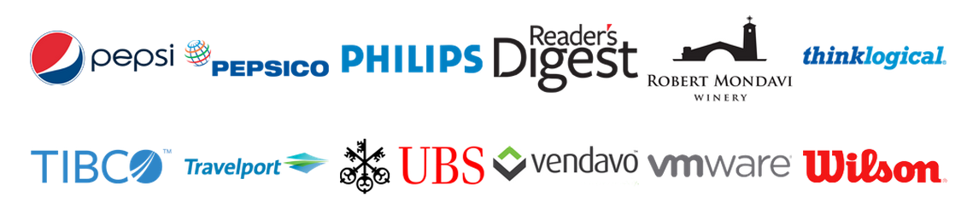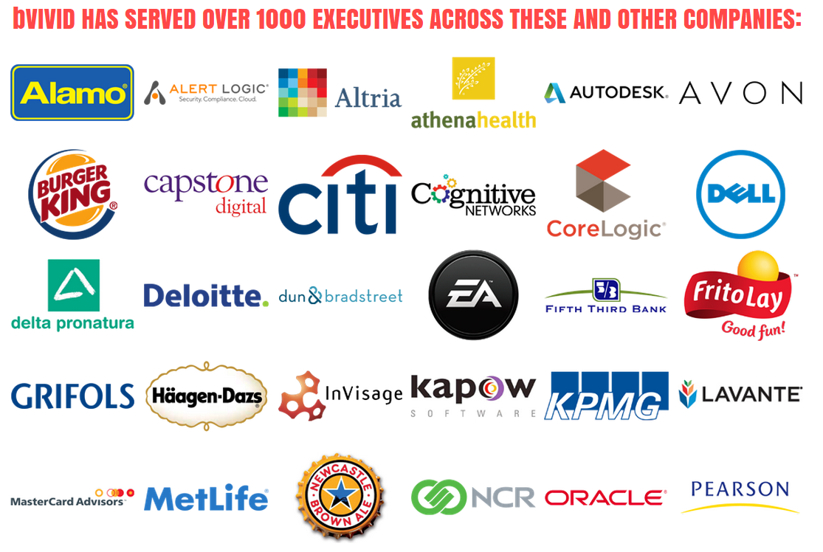

1. **Call to action and contact info:**

In markets where everyone is pitching and everyone is being pitched,

communications must be vivid: crisp, evocative, and hard to ignore.

Send us what you’ve got or tell us what you need.

Within 48 hours we’ll return a brilliant idea.

Love it and we’ll talk, if not we’ll part friends.

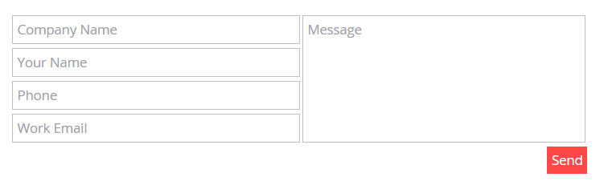

*b*VIVID

1115 Broadway, 12th floor

New York, NY 10010

(917) 635-2118